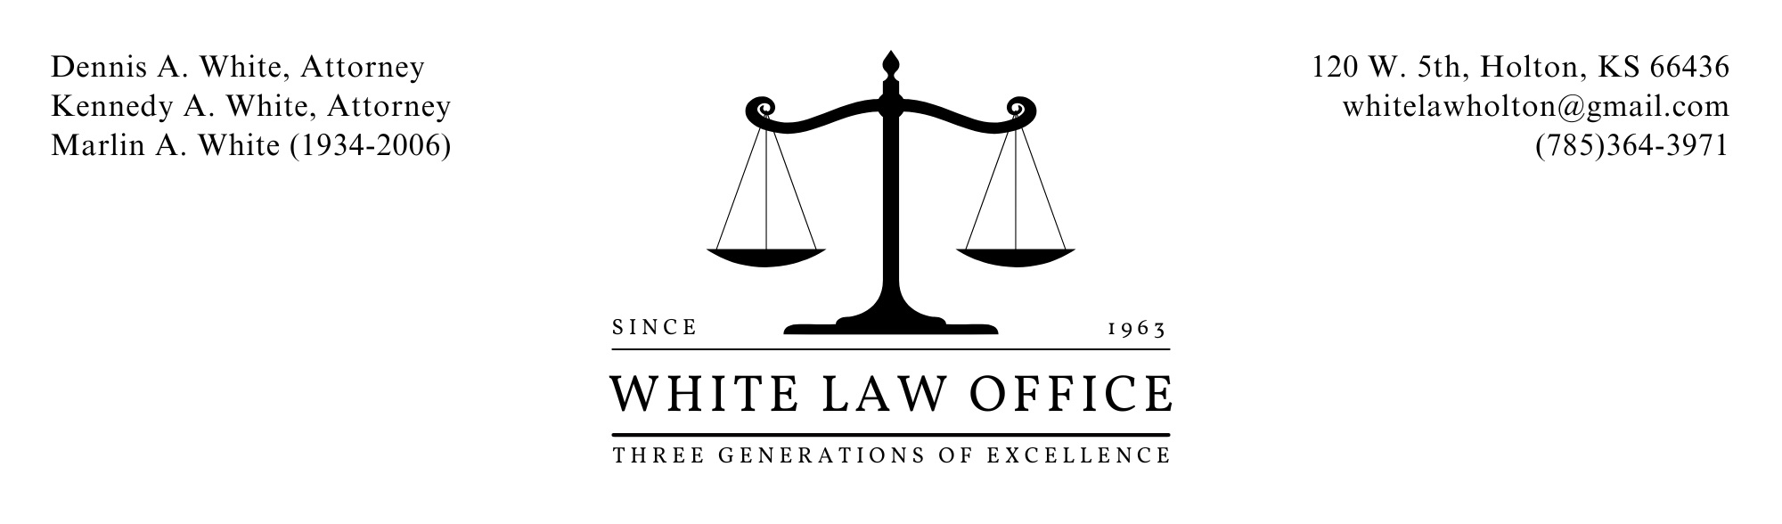
ESTATE PLANNING APPOINTMENT LIST
Hello,
Thank you for choosing White Law Office to discuss estate planning. As the leading provider of these services in the area, we look forward to working with you.
To best serve you, there are a few items you should bring to your first appointment. We have provided a checklist of those items below.
- Any existing Last Will and Testament and/or Trust Agreements
- Any health care and business Power of Attorney.
- Deeds to residence and any other real property which you own – we can access most Kansas County’s records if you cannot find these.
- Recent statements for all bank, brokerage, retirement or other accounts.
- A list of life insurance policies or annuity contracts and the name of current beneficiary.
- Names and addresses of individuals you plan to leave inheritances to and individuals you’d like to help manage your estate during and after your lifetime – please also list their spouses and children.
Please do not worry if you are not able to gather all of the above information prior to your appointment. If you are missing something that we believe is important to review, we can help you obtain the desired information following your appointment.
If you have any questions, please reach out to our office at 785-364-3971.
Sincerely,

White Law Office

